**Keegan Smith**

**Electromechanics HW1**

**Submission Date:** 2/2/23

**Due Date:** 2/3/23

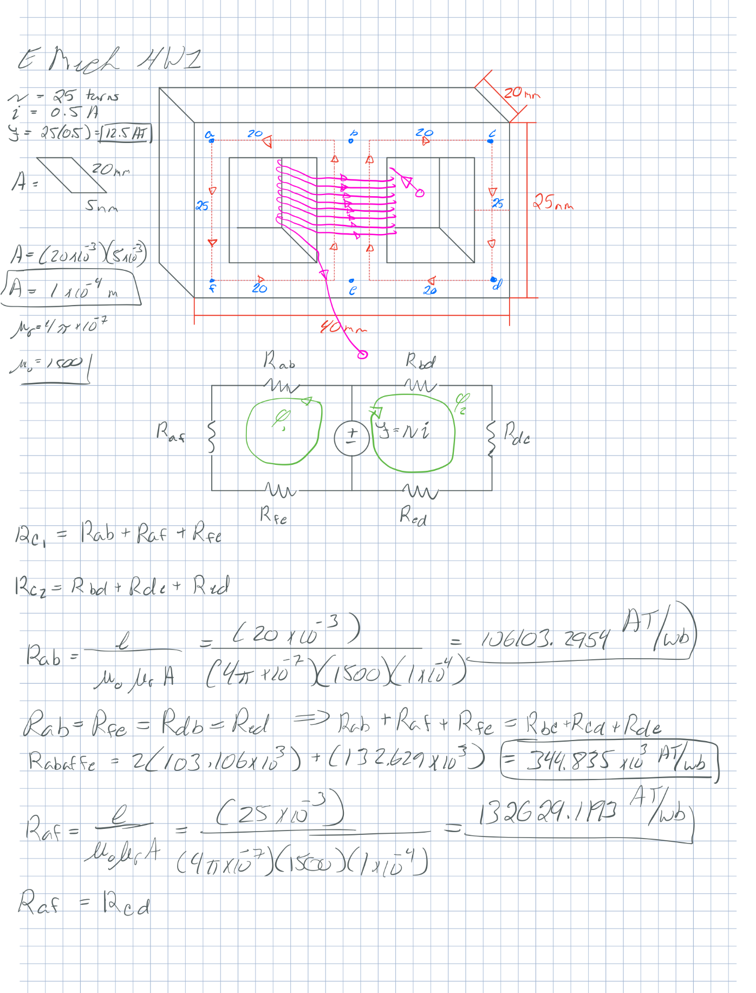**Hand calculations page 1**

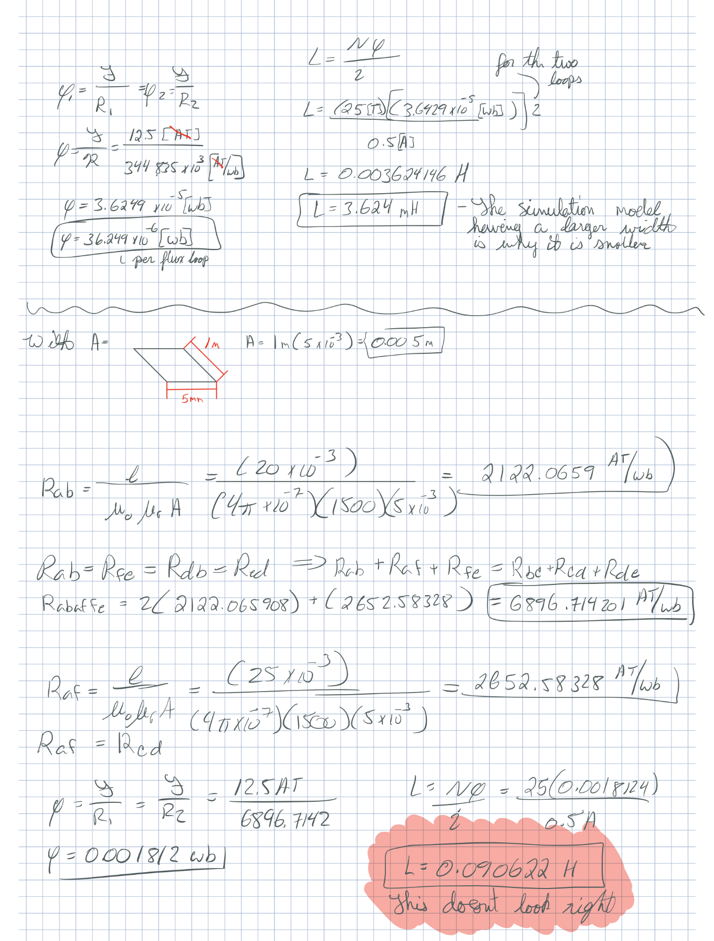**Hand calculations page 2**

**Hand calculations page 3**

**Simulated model and mesh plot**

**Flux lines and Magnetic flux density distribution**

**Magnetic flux density vectors and Inductance value**

**Magnetic flux density distribution plotted over the red line (as seen in the simulated model) and the average value of the flux density**

**Data comparison**

The comparison of inductance values between my two calculations, and the simulation raises questions. The simulation value found 308.3879[uH]. However, my calculations of the given model yielded 3.624[mH] and for the simulated model, 90.622[uH]. Seeing how close the B-field calculations are, I am not quite sure what went wrong to have these values so far off. I would expect the given model’s value to be different since the cross-sectional area is smaller, but I would still expect the hand calculated value of the simulation to be closer than a 70% error.

Looking at the Mag_B plot from Ansys, we see the average B-field was 384.2098[mT], and looking at my hand calculations of the given model and the simulation model, the B-field value was 362.4[mT]. After a quick percent error calculation using the calculated value as whats expected, I found a percent error of 6%. Which is not ideal, but issues could lie with my calculations, or my simulation based on my introductory experience with the software.